Adding Alternative, or Alt Text, to Facebook Posts

Desktop Application

Adding Alt Text to New Posts
Select the Photo/Video option for a new post.
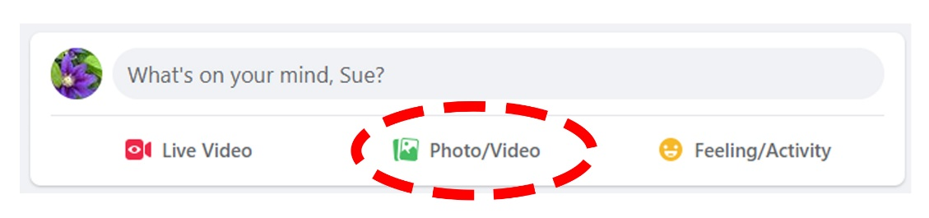
Navigate to the image you want to add to your post, select it, then select Open. The image will then appear in the posting pop-up. Hover your mouse over the image and you will see the Edit option in the upper left. Select the Edit option.
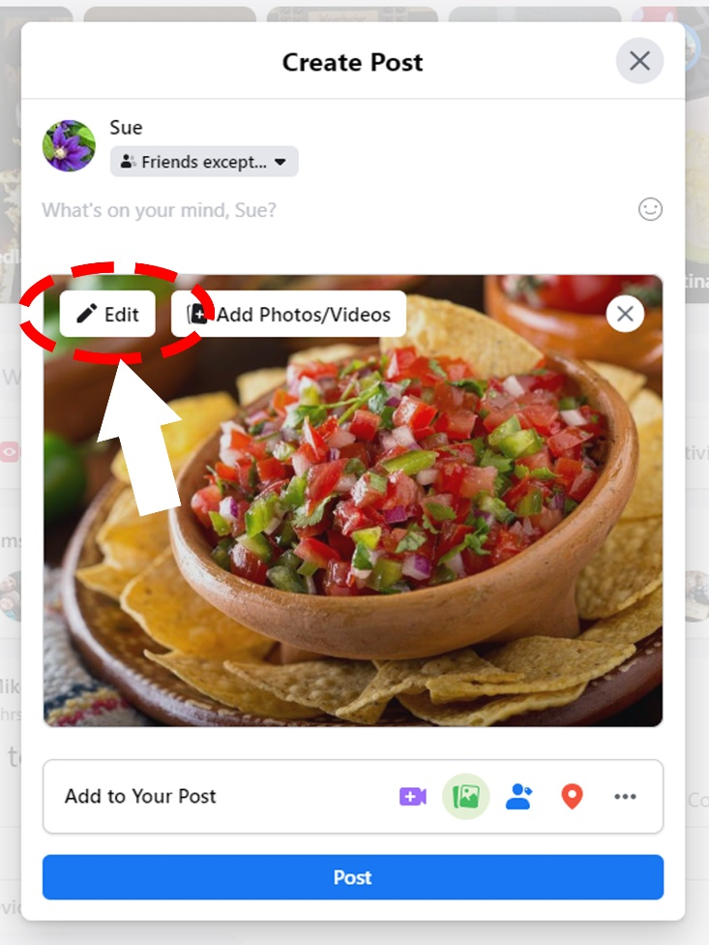
In the Photo Detail pop-up, place your cursor in the Alternative Text box and type your text. When finished, select Save at the bottom left. Then select the back arrow at the top left.
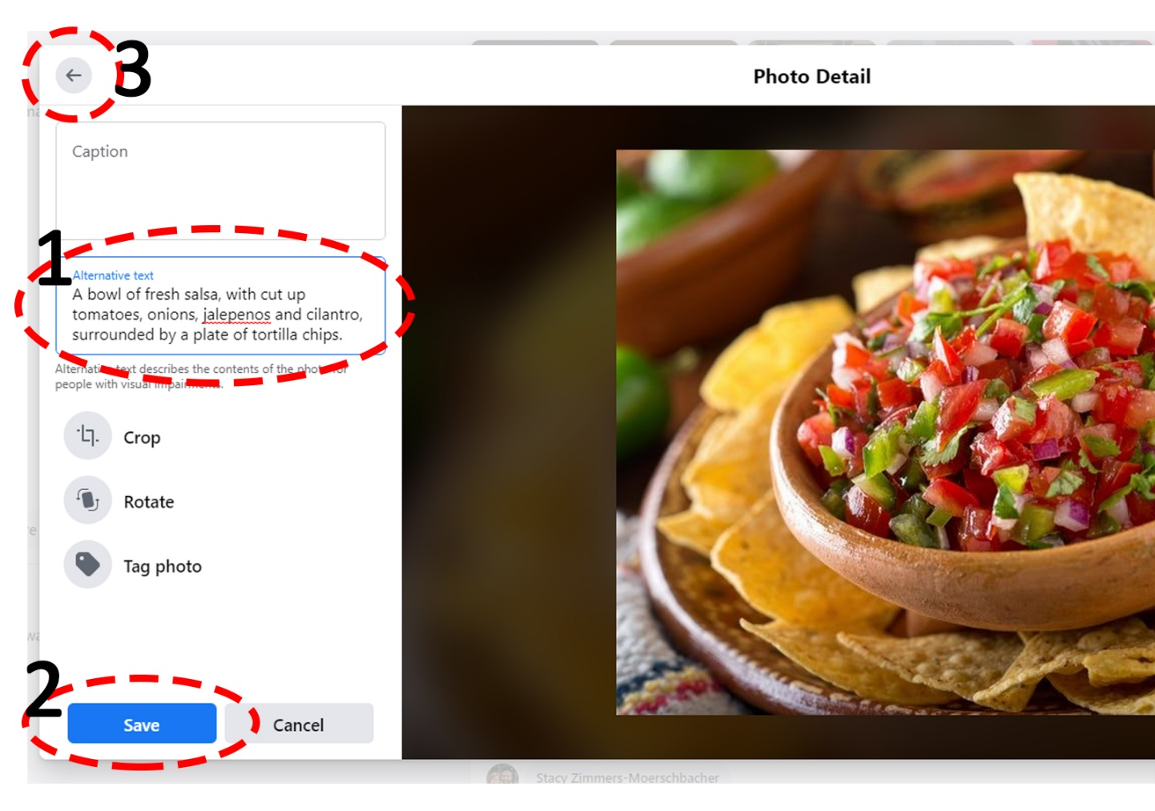
Back on the Create Post screen, enter your posting content. Remember to use plain language, keep it short, and provide content first, then hashtags and finally any links you may supply. Remember to use camel case if your hashtag contains more than one and to use a link shortener, like Bitly, before pasting your links into the post. Select Post once you have finished entering this information.
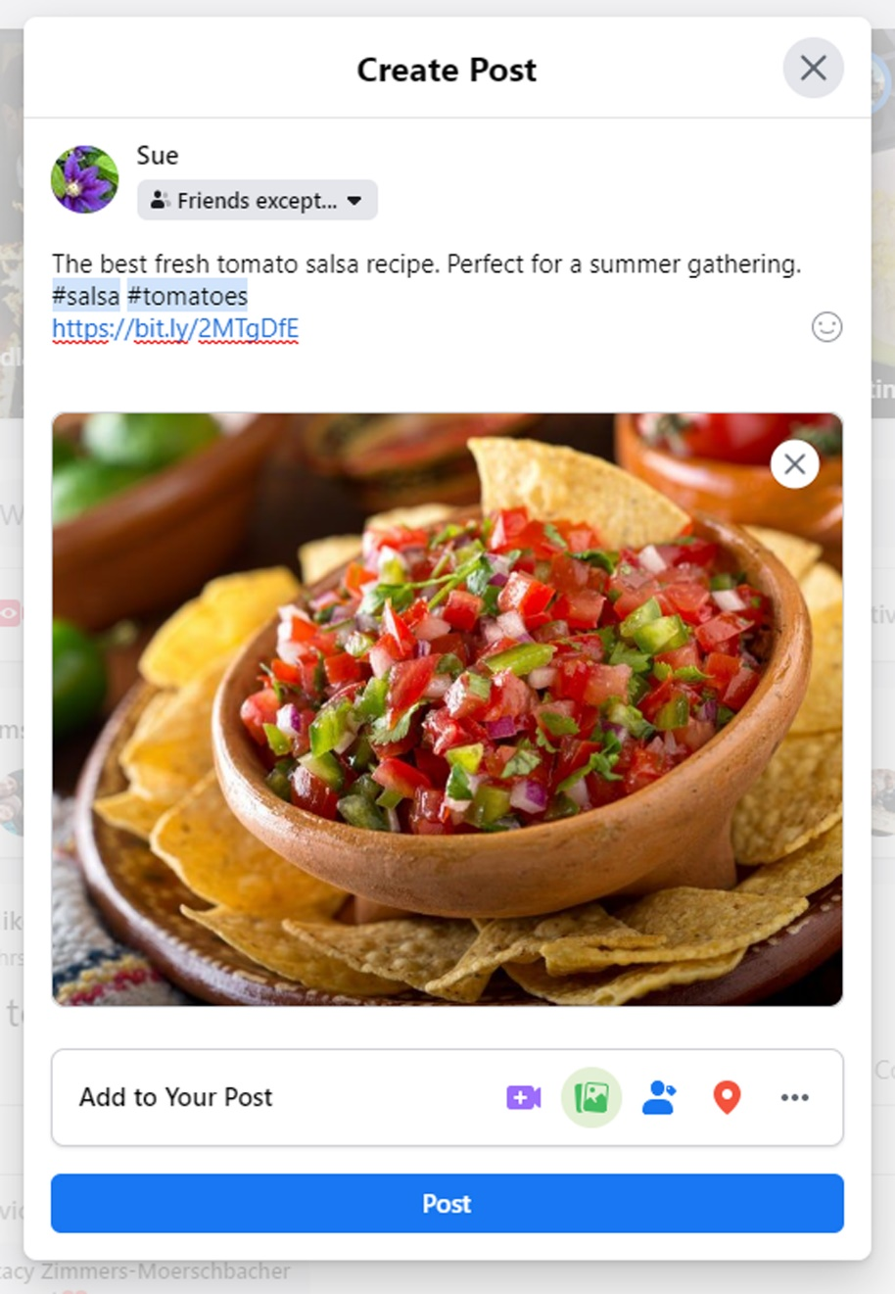

Adding Alt Text to Existing Posts
First, go to your page and navigate to the post that contains the image for which you want to add alt text.

The screenshot above shows a post with two images. There is an arrow and bulls-eye on the left picture, indicating that you would select, or click on, the picture for which you want to add alt text.
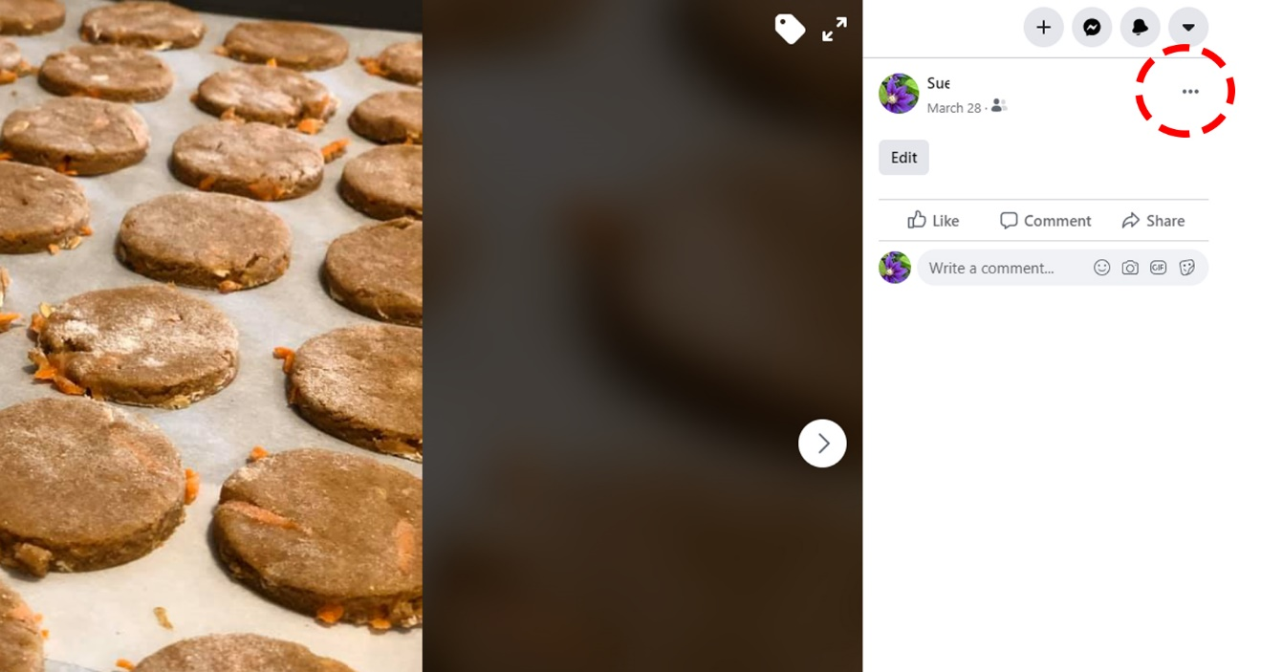
One you’ve selected the image, you will see an enlarged version of your picture. In the upper right of the screen, you will select the ellipsis to open additional editing options.
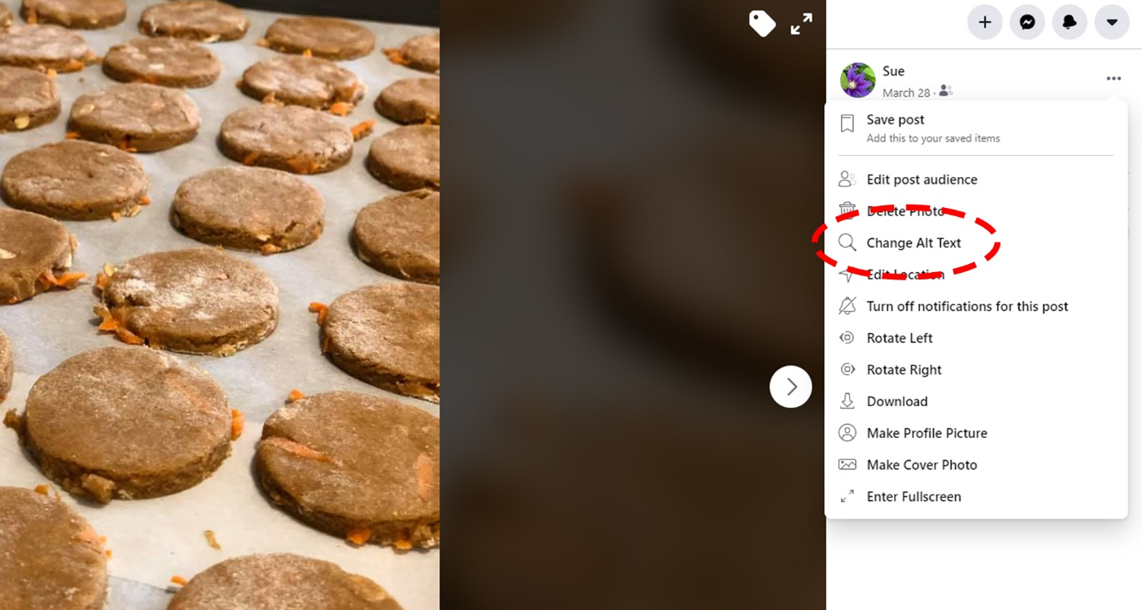
A pop-up menu will appear; you will choose the Change Alt Text option.
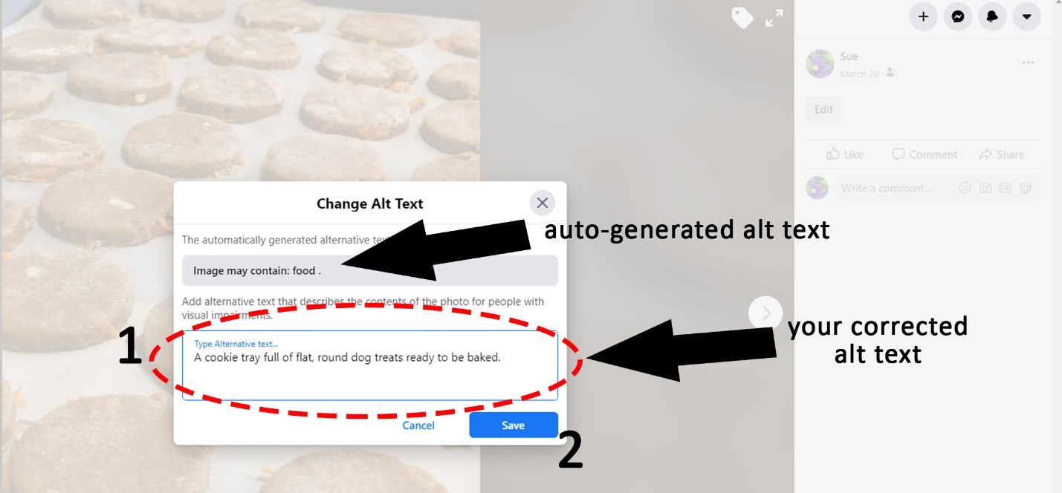
The Change Alt Text pop-up will appear. Towards the top you will see the auto-generated alt text Facebook has supplied. In the Type Alternative Text box, you will enter your corrected alt text. Select Save when finished.
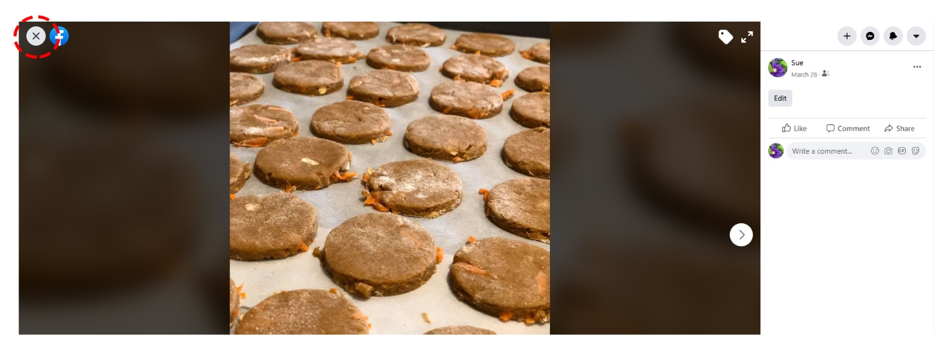
Once you have saved your corrected alt text, you will be taken back to the screen with the enlarged version of your image. To exit this screen, select the X in the upper left corner.

