Adding Alternative, or Alt, Text to Facebook Posts

Mobile Application

Adding Alt Text to New Posts

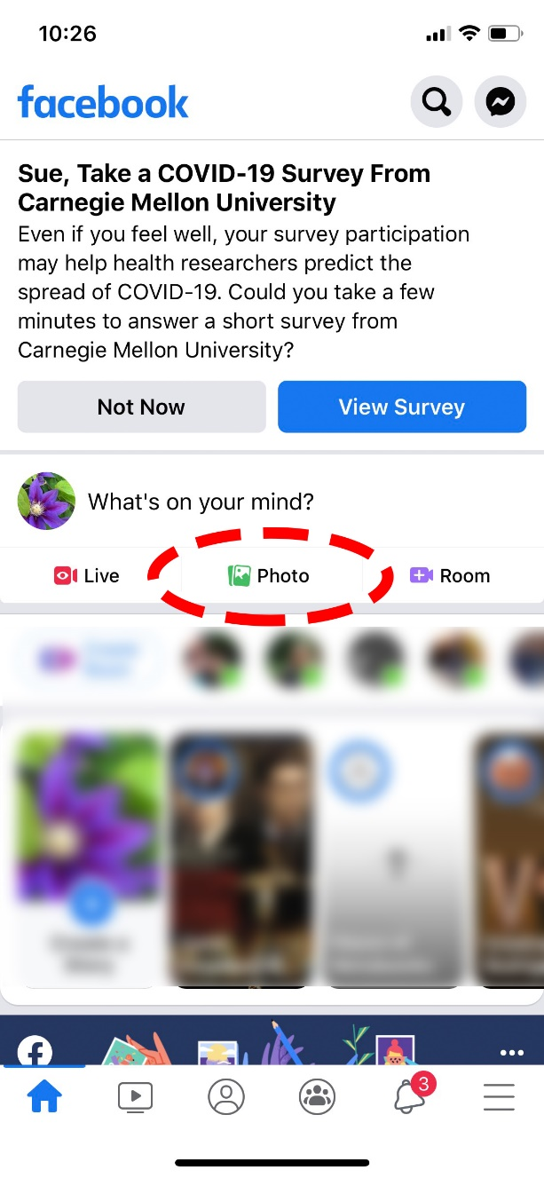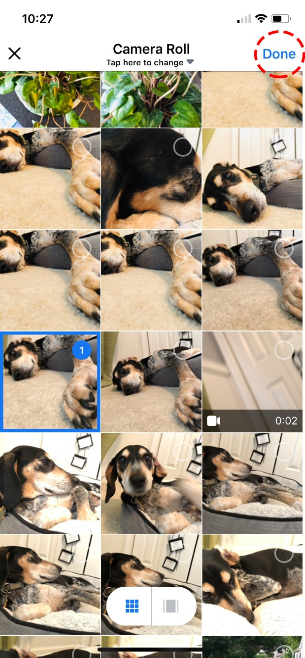
As you can see in the screenshot on the left, you will start by selecting Photo from the options on the Facebook mobile screen. As shown in the screenshot on the right, you will then navigate to the image you wish to use, tap to select it and then select Done in the upper right corner.
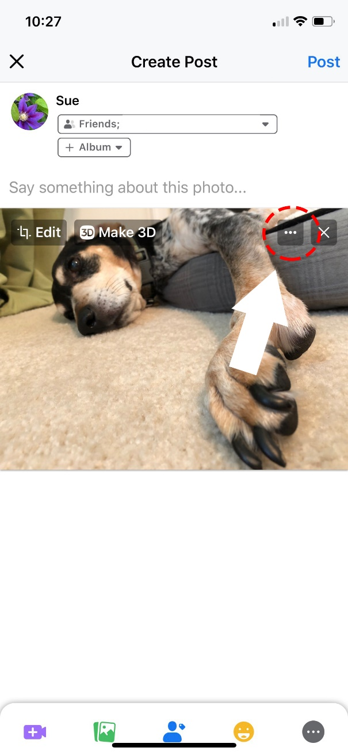
You are then returned to the Create Post screen as seen in the screenshot on the left. Tap the three circles, or ellipsis, in the upper right corner of the image to get additional editing options. Once you have done that, you will be provided several options including the option to Edit Alt Text, as show in the screenshot on the right. Select this option.
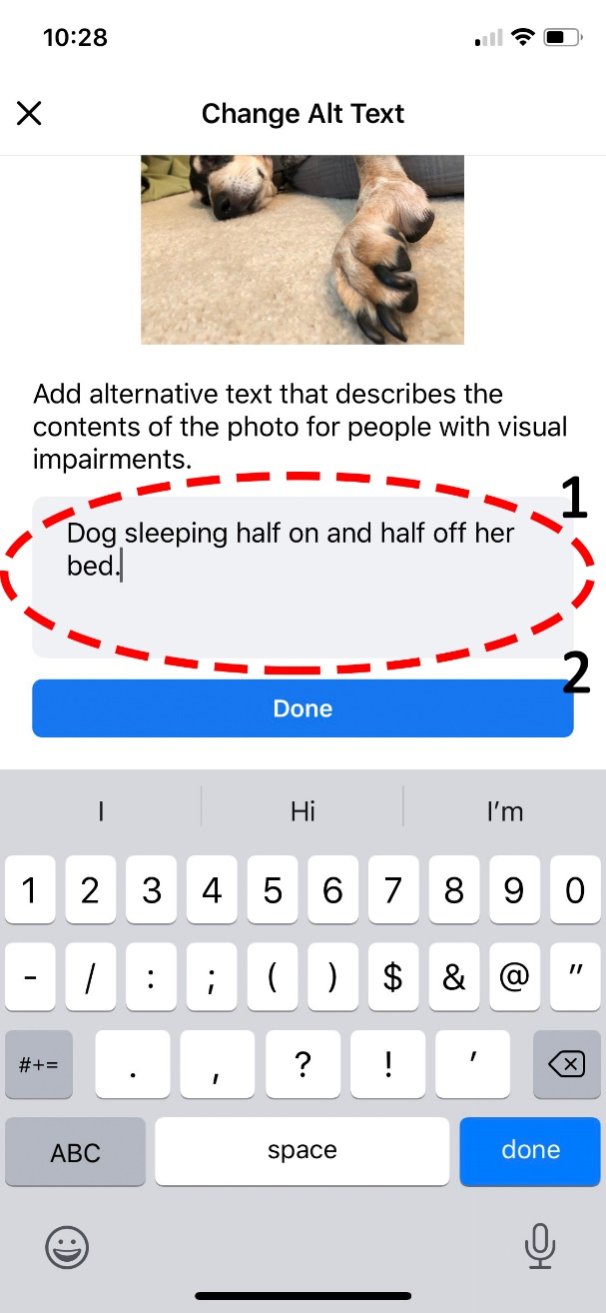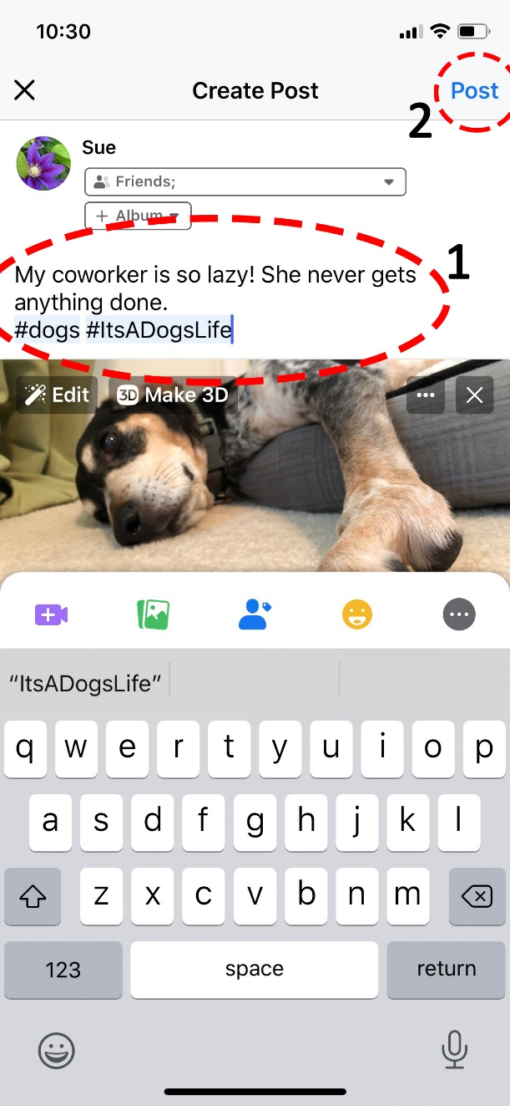

After selecting the Edit Alt Text option, you are taken to the Change Alt Text screen as shown in the screenshot on the left. Use the textbox provided to enter your alt text description. Once you have completed typing your description, select Done. This will take you back to the Create Post screen, which you can see in the screenshot on the right. Here, you can enter your posting content, hashtags and links where applicable. Remember to use camel case if your hashtag contains more than one word; in other words, do not leave spaces between the words and capitalize the first letter of each word. Remember to shorten any links you provide.

Adding Alt Text to Existing Posts

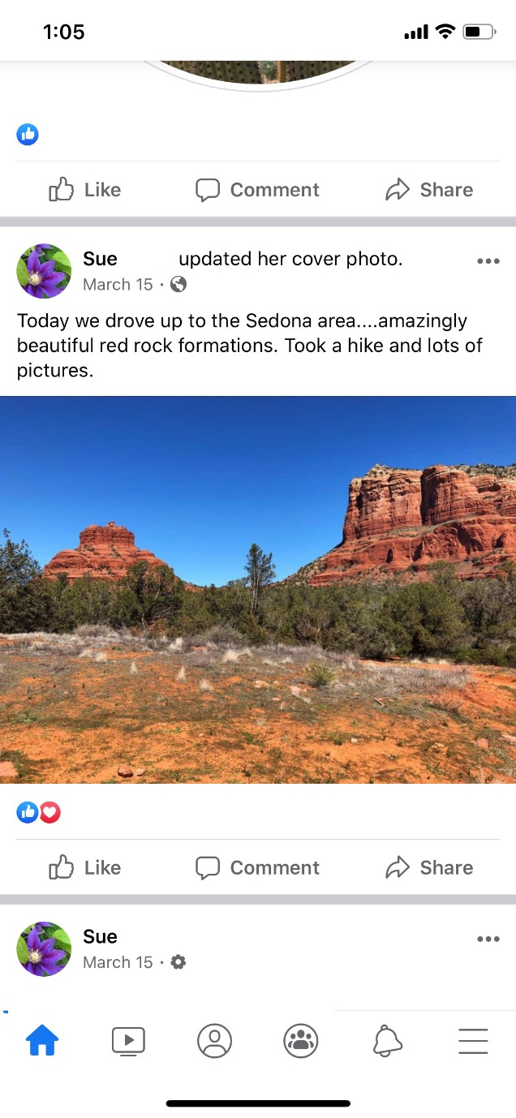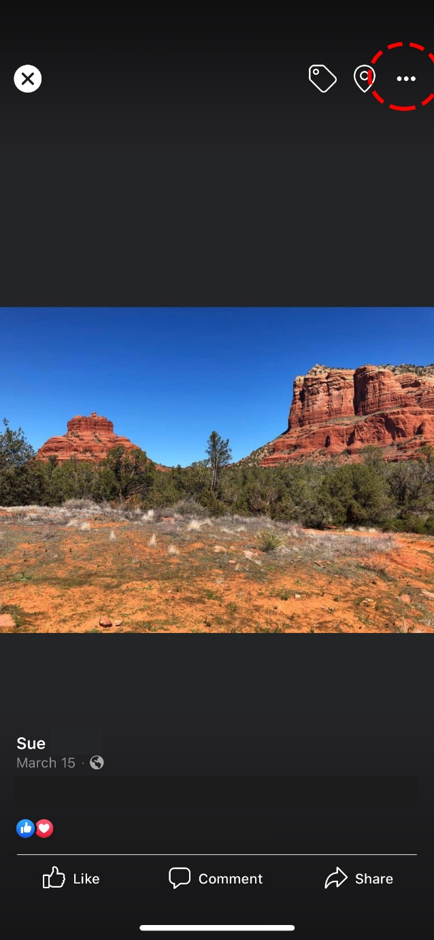

Navigate to the post that contains the image for which you want to add alt text. Tap on the image to select it. You will now see a black screen with the image featured. In the upper right corner of the screen, select the ellipsis, or three dots, for additional editing options.

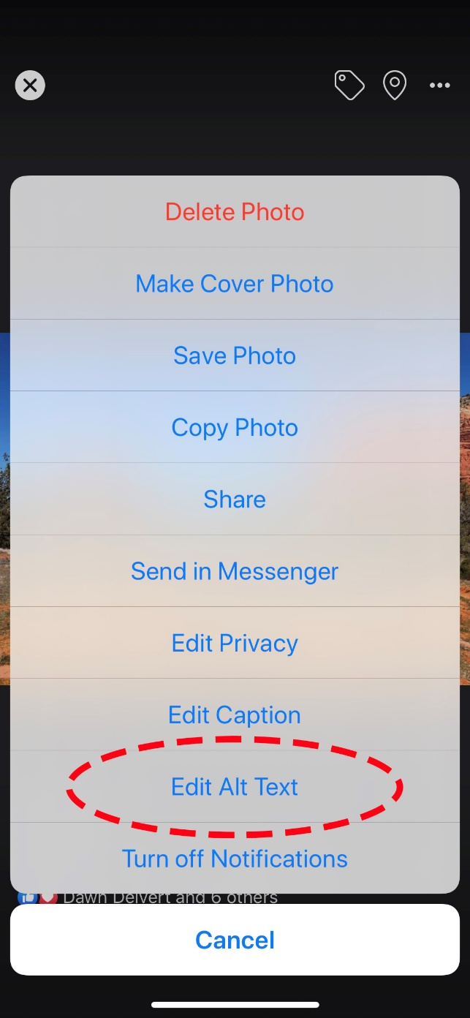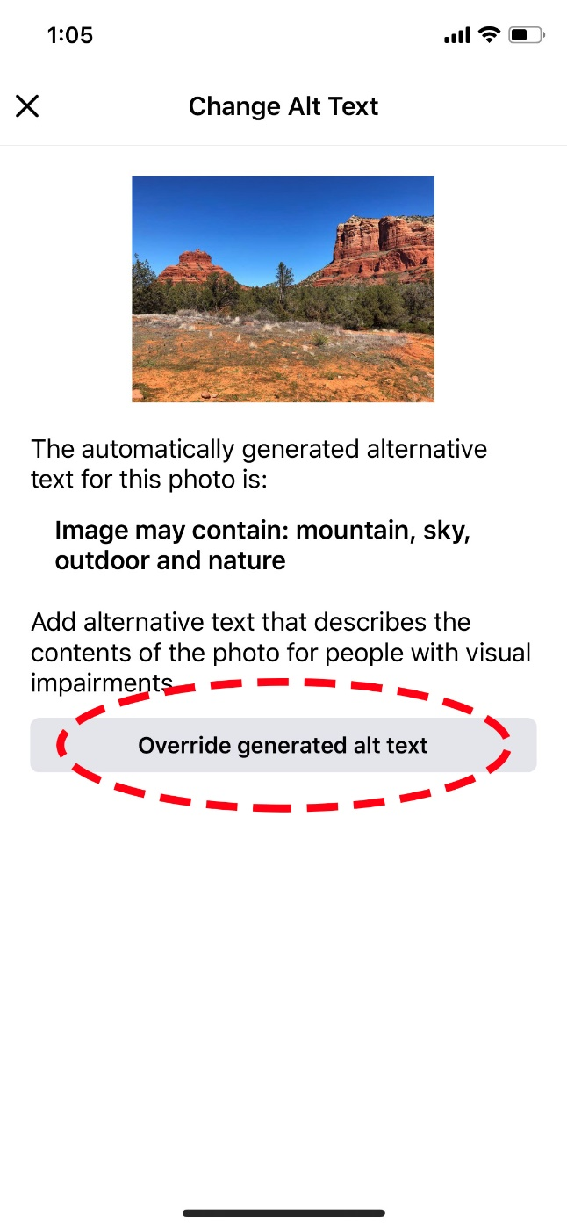

Once the editing options menu appears, select the Edit Alt Text option. As you will see on the screenshot at the right, on the Change Alt Text screen, Facebook will auto-generate alt text. You will want to select the Override generated text button so that you can add your own alt text.
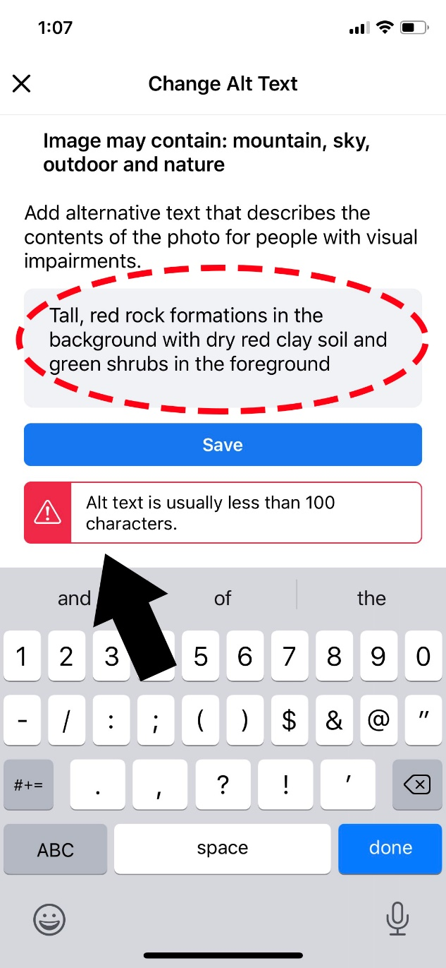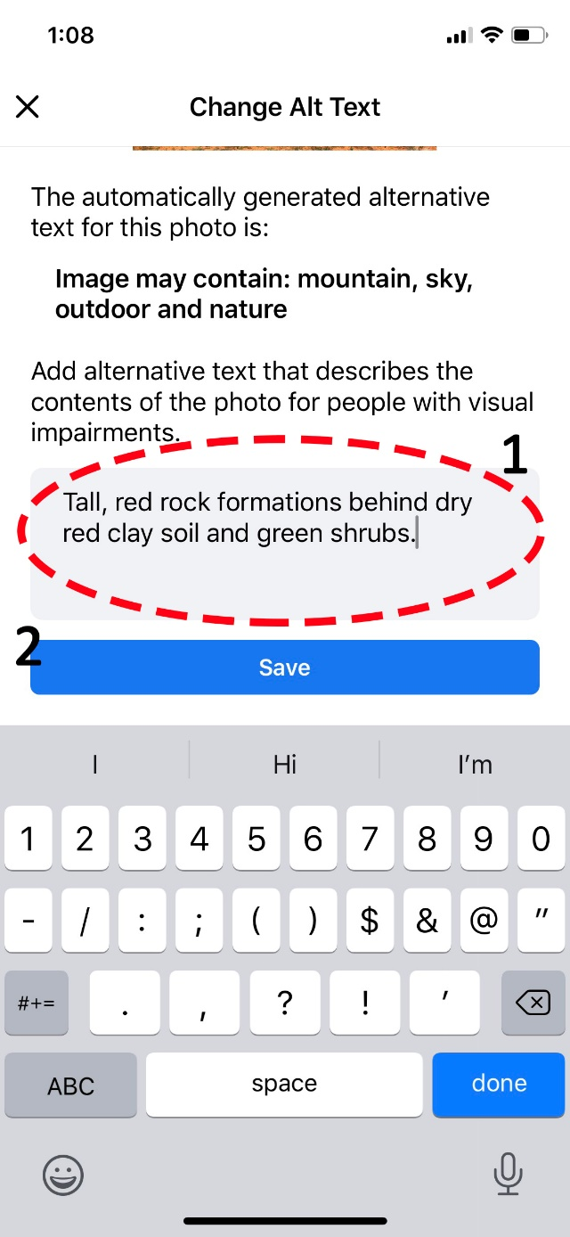

Start adding your alt text in the textbox provided. Please note the screenshot on the left shows a warning that the alt text description exceeded 100 characters. If you receive such a warning, you may want to shorten your text. You can see a shortened version of this alt text in the screenshot on the right. Once you have entered the corrected text, select Save.

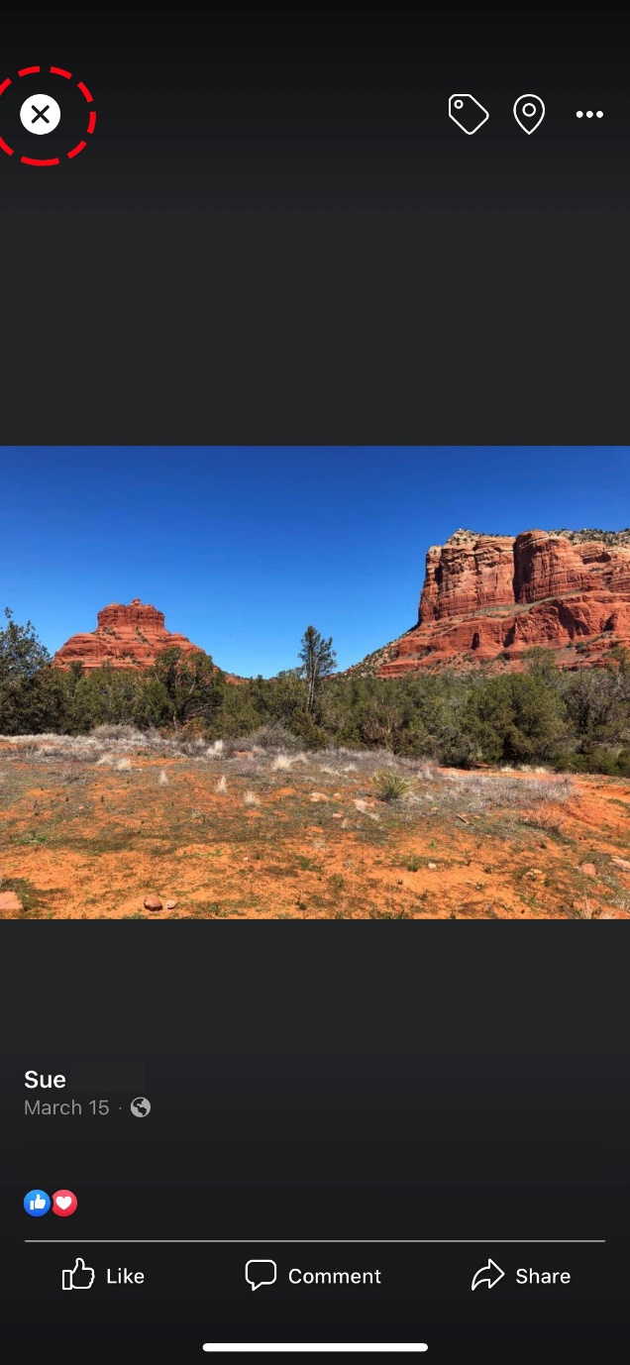

Now that your alt text has been entered and you have saved it, you will see your image surrounded by a black screen. Select the X in the upper left corner of the screen to exit out of the image editing mode and back to your page.

