Make Instagram Posts Accessible

Alt Text in Instagram
Upload (or take) your photo to Instagram.
Write your caption. Add hashtag with in camel case, capitalizing the first letter of each word.
Select on “Advanced Settings” at the bottom of the screen.
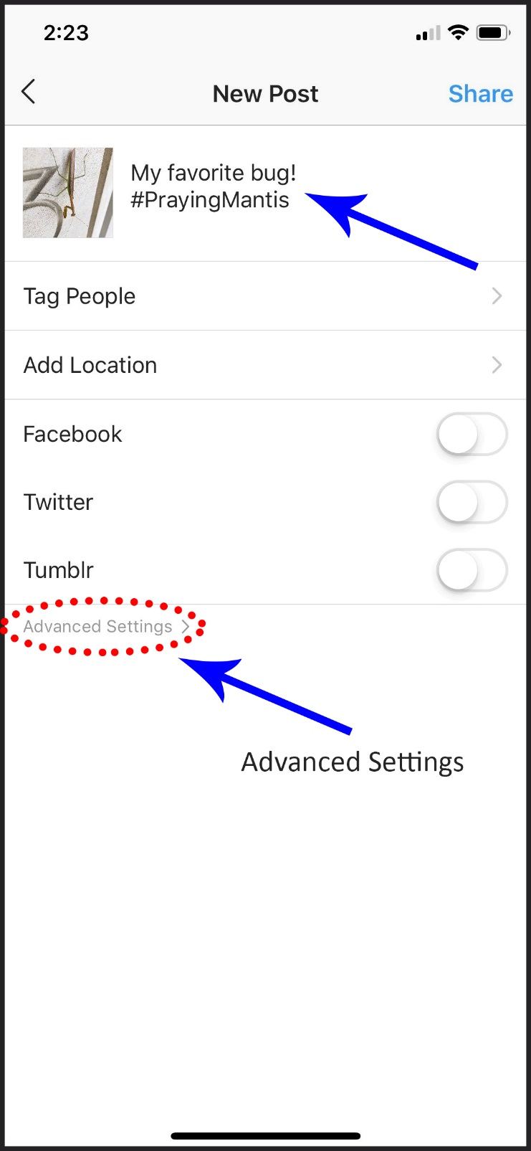
Select “Write Alt Text”.
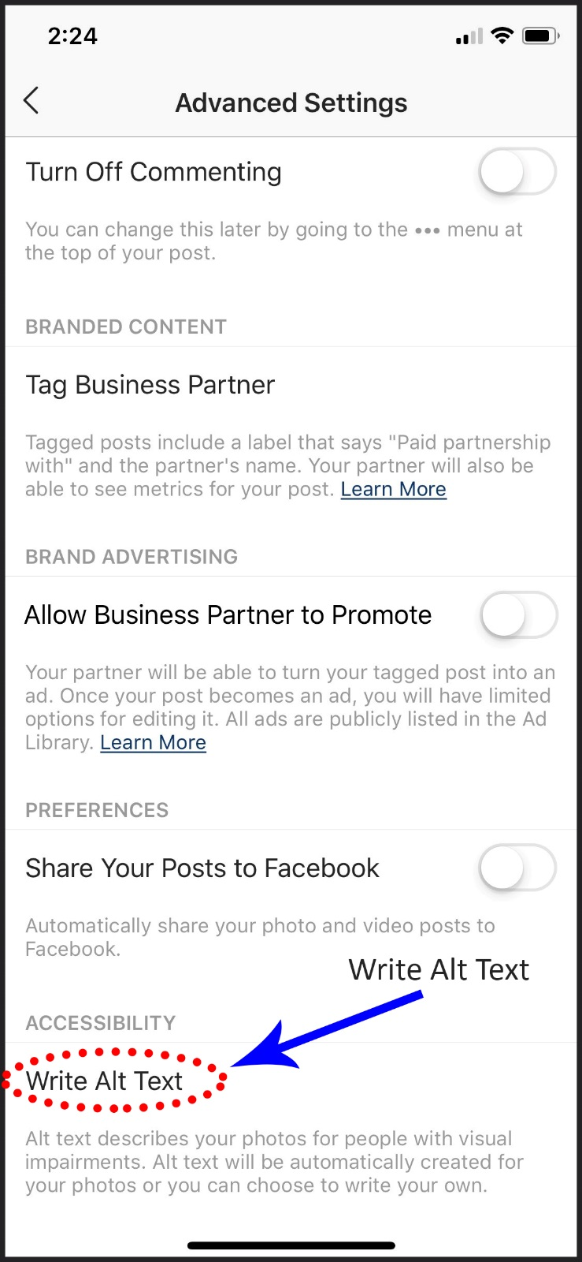

Enter your alt text description and select on “Done”.
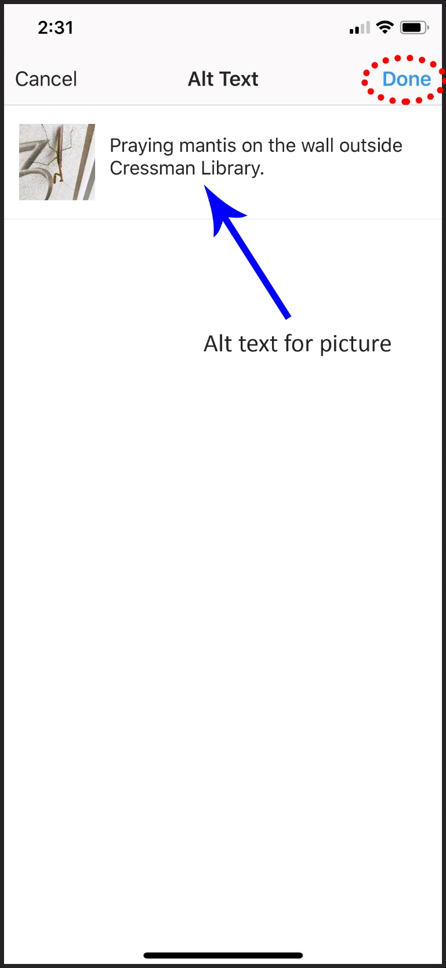
Select on the back arrow to get to the posting screen.
Select "Share” to complete your post.
Your photo/graphic is now shared and alt text regarding the content of the graphic is available to anyone using screen readers.

