Make Outlook Emails Accessible
The following Microsoft document provides guidance on how to make your email accessible:
Make Your Outlook Email Accessible to People with Disabilities (Links to an external site.)
Of particular importance is adding Alternative Text, or alt text, to email images and graphics. So often, we send colorful and creative announcement graphics in email that convey a lot of information about events etc., but the information is not accessible to students using screen reading software. This is because the pertinent information is embedded within the image/graphic and no alt text is provided.
Adding Alt Text to images in Microsoft Outlook Emails
Let’s consider the following email. I entered a graphic which has all the information about the event in it. Because it is a picture, the information about the event is not accessible to students using screen readers.
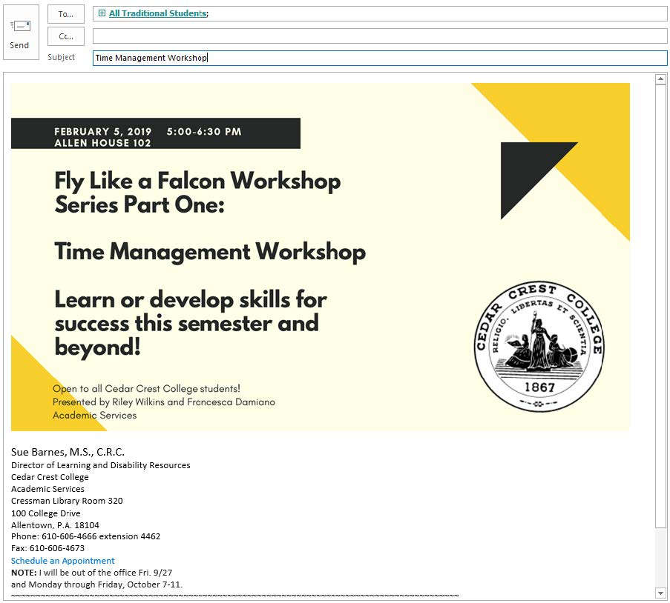
There are two options for providing access to this information. The first is to provide alt text for the image/graphic and the second is to provide the event information in addition to putting the event image/graphic within the email. The following are instructions on how to add alt text to the image/graphic.
In order to allow them access to this information, we must provide it in an alternate way. The first way we can do this is to add alt text to the image. To add alt text, right click on the image and select Picture/Format Picture.
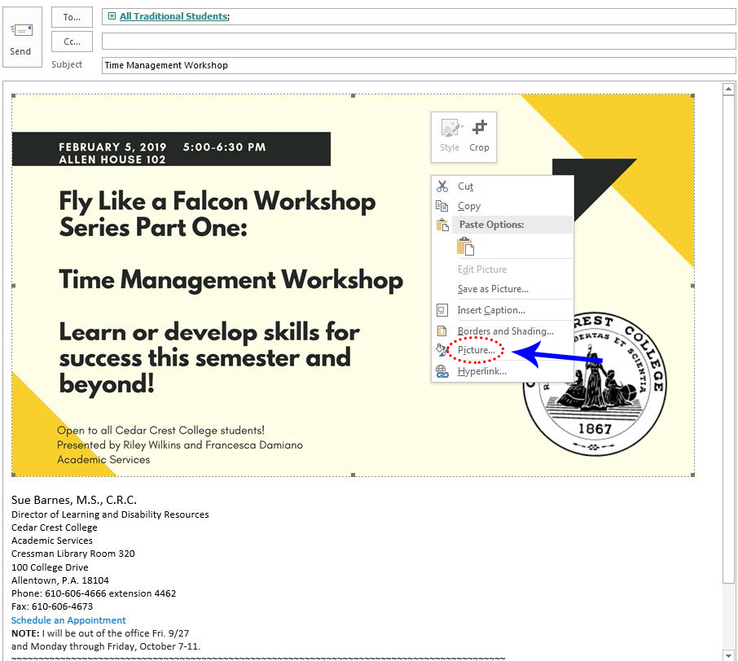
Select the “Alt Text” tab/heading. Select inside the text box, add your text (if given the option to add a title, you do not need to do so) then select OK.
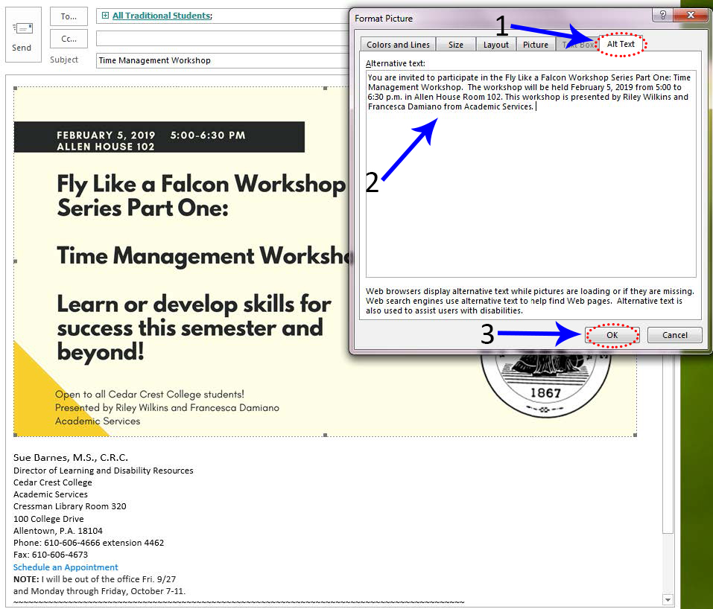
The second option to provide the event details below the image/graphic, as in the following example:
