Student Instructions
Contents
Video Links 1
Smarthinking Homepage 1
Tutoring 2
Writing Reviews 4
Archives 5
Study Aids 5
Technical Support 5

Video Links
Two Smarthinking overview videos:
- Student video (1 minute, 34 seconds)
https://www.youtube.com/watch?v=rWIstHbWoKM&feature=youtu.be
- More detailed video (5 minutes, 3 seconds)
https://www.youtube.com/watch?v=iW0ajIFM0Nw

Smarthinking Homepage
After logging onto Smarthinking, the Smarthinking homepage appears:
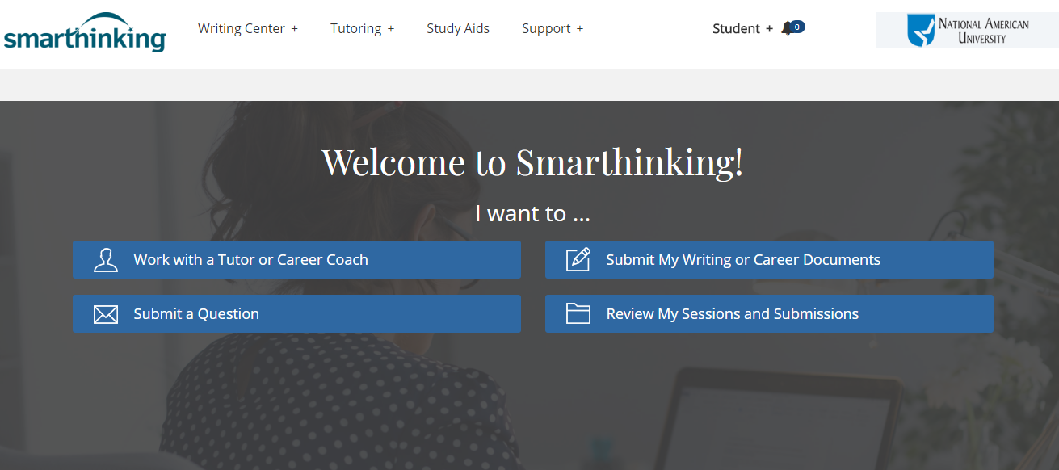

Three “How to Use Smarthinking” videos are at the bottom of this page:
- How to Use Drop-in Tutoring
- How to Use a Whiteboard
- How to Use Writing Feedback
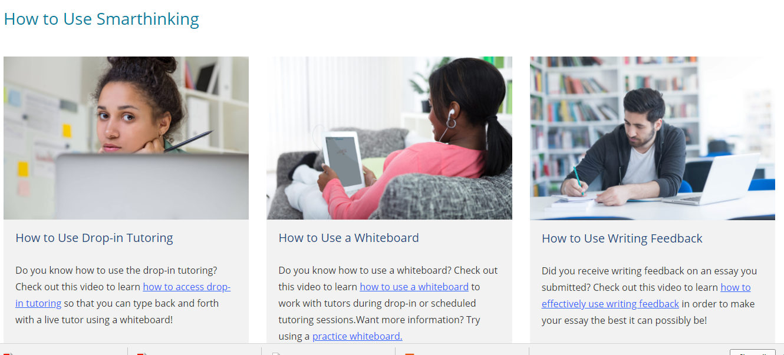

When the logo in the screen’s upper left is clicked, the homepage returns.

Tutoring
Click on “Work with a tutor or Career Coach” to --
- Join a live, drop-in session.
- Schedule a Future session.
- Ask a question and receive a response within 24 hours.

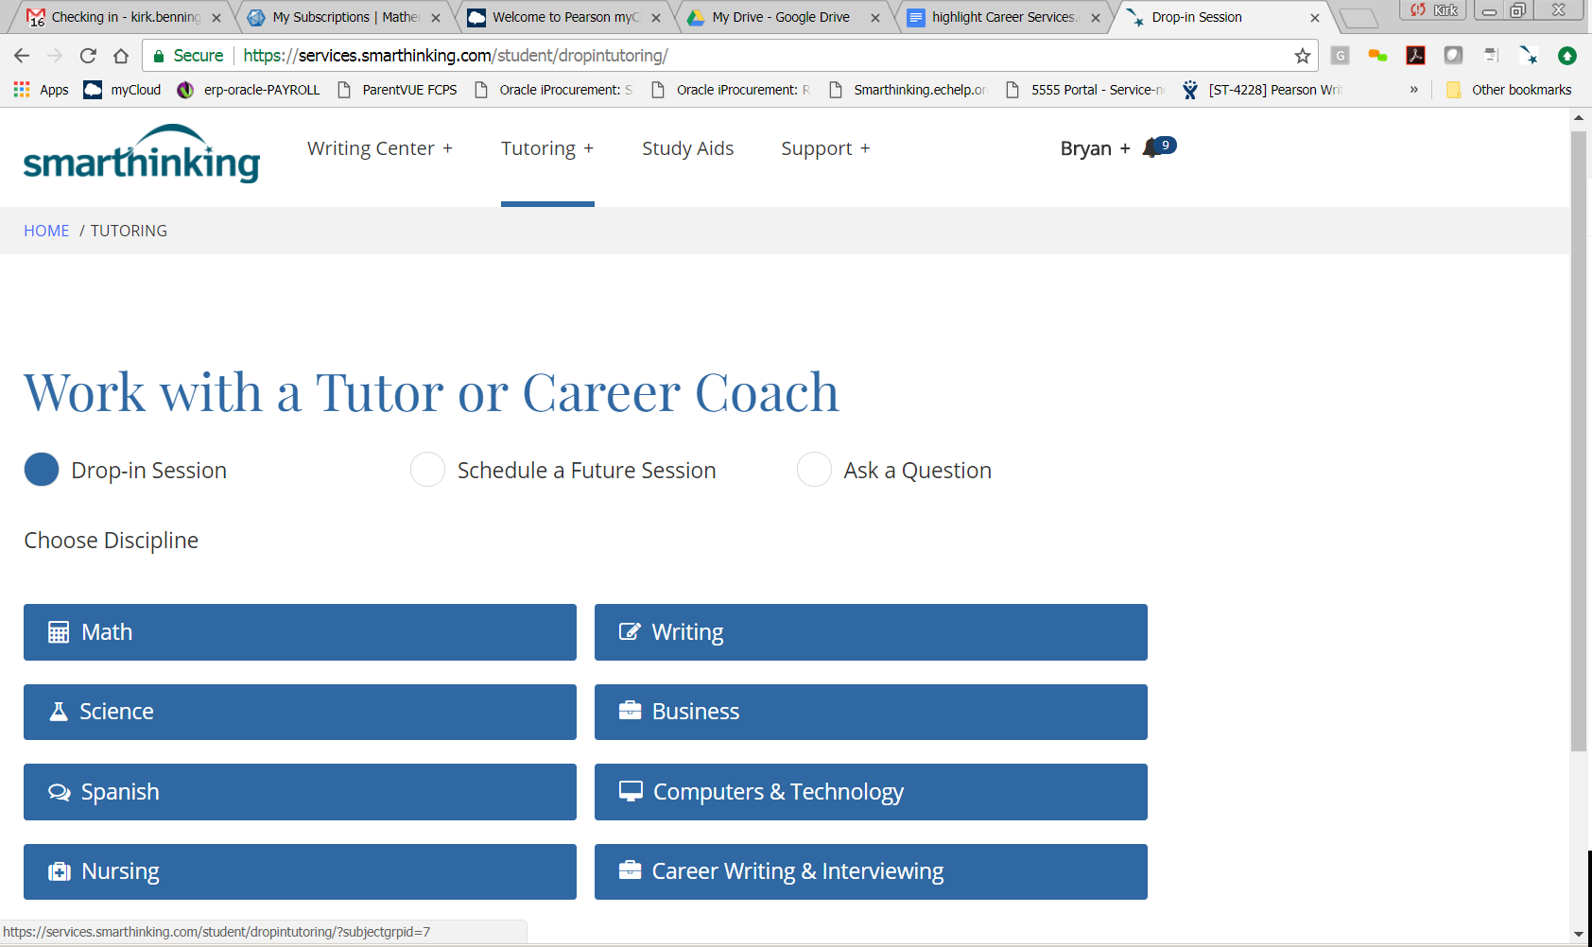

- Click on the subject (a list of subtopics may appear):
For example, after clicking on “Nursing,” these subtopics appear:

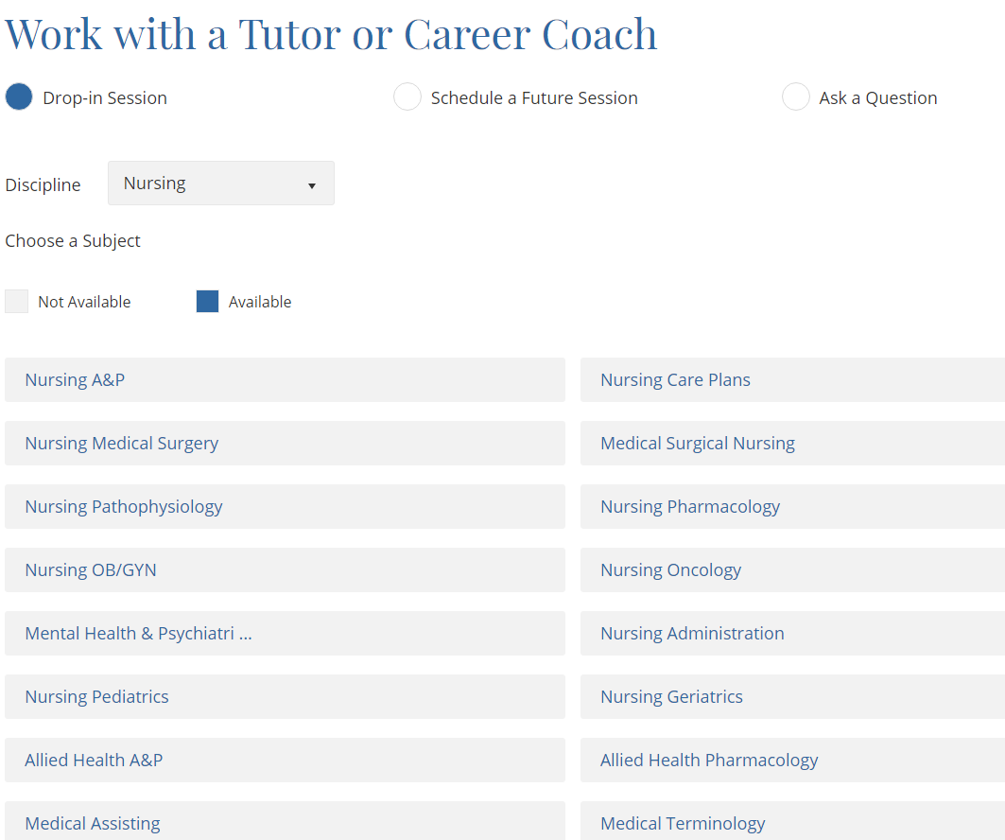
When a session is launched, a whiteboard appears:
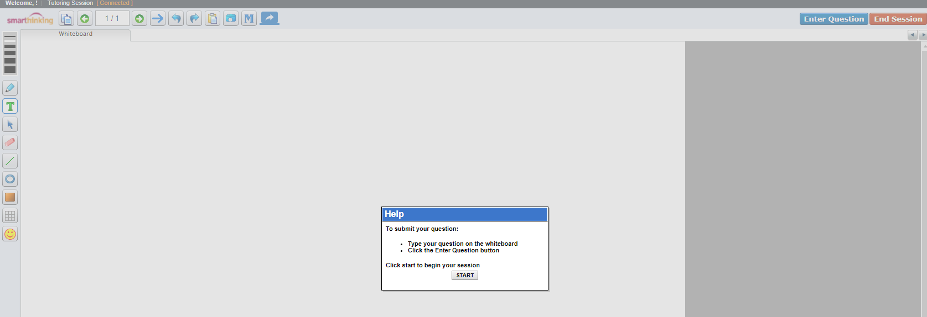
- Click START, and write the problem.
- When “Enter Question” is clicked, a tutor joins the session.

This link to a video of a live tutoring session shows how a student and tutor interact (speeded up in a movie format): https://youtu.be/ATQve_N99iE

Writing Reviews
Click the “Submit my Writing or Career Documents” link:
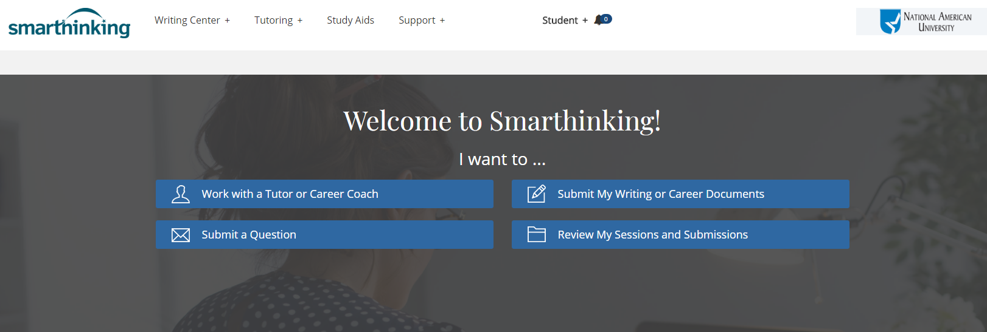

These types of writing may be submitted for review:
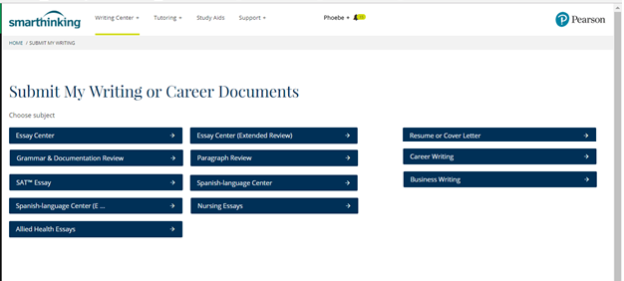
Fill out the form, informing the tutor of the assignment and what kind of help is needed:
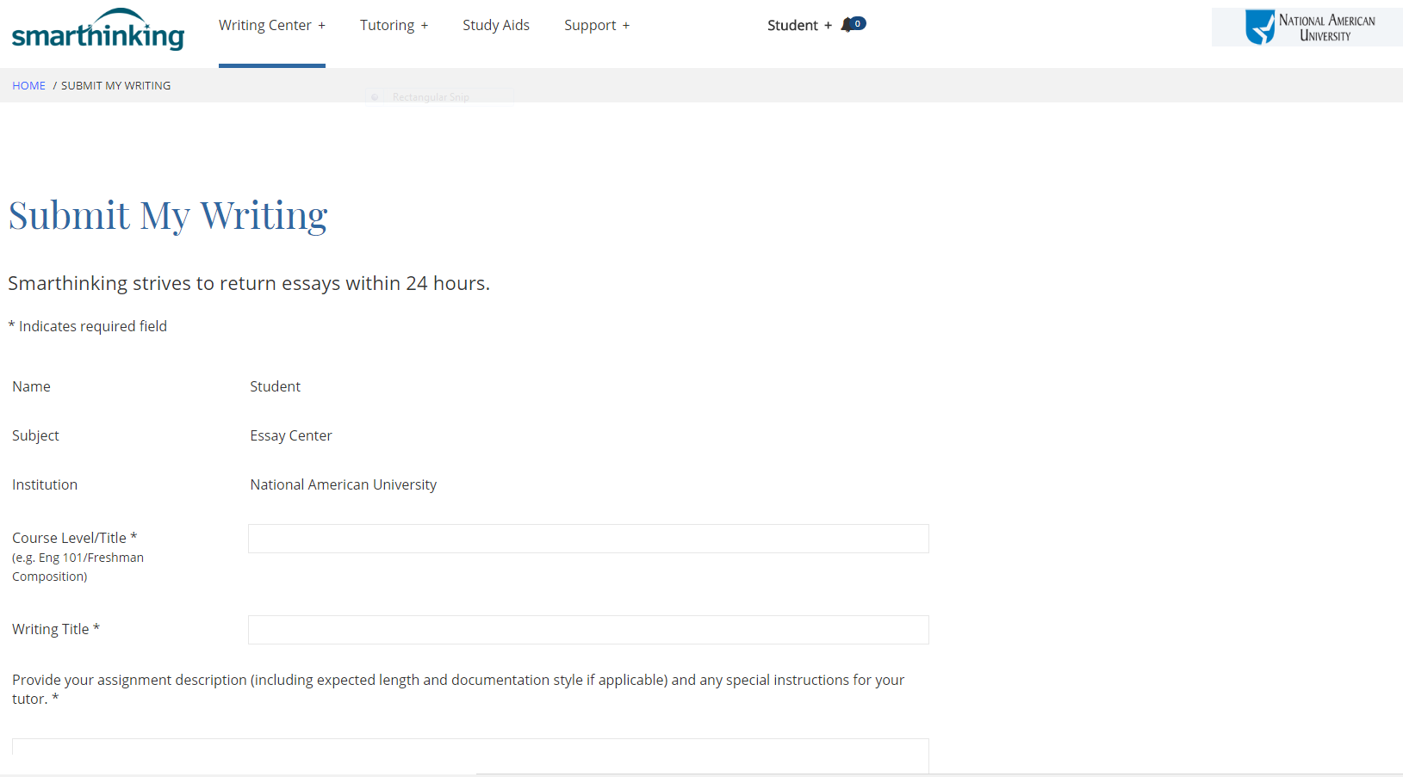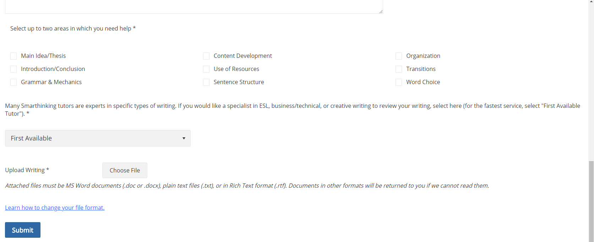

Archives
Tutoring session transcripts and writing reviews are in the “Review My Sessions and Submissions”:
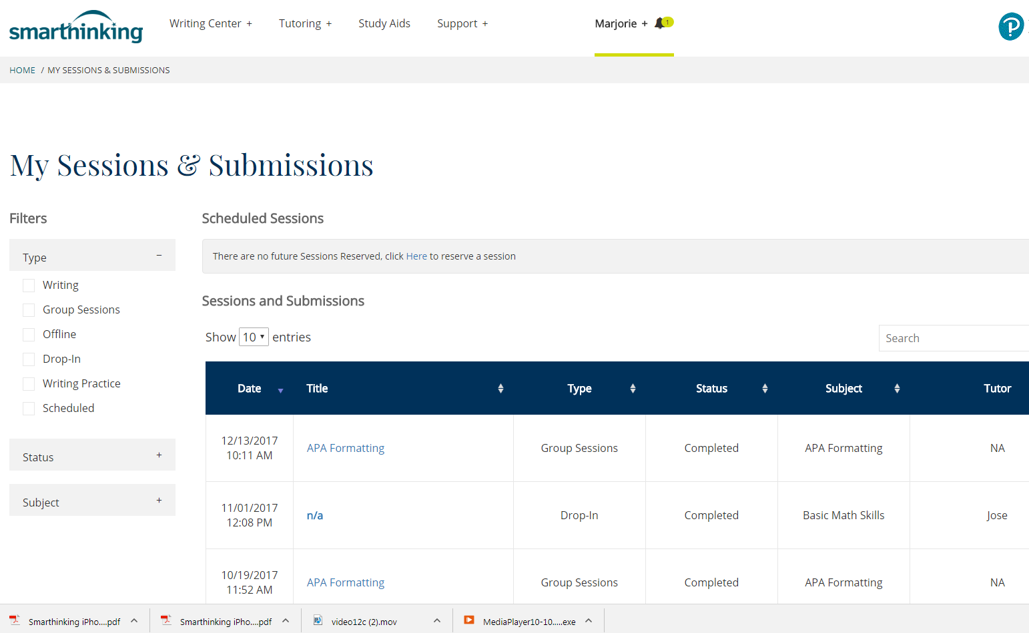

Study Aids
Many other resources are available through the “Study Aids” link at the top of the Smarthinking homepage, including video lessons, handbooks, documents, podcasts, learning objects, animations, graphics, figures, and interactive tutorials. These resources may be used as often as needed.
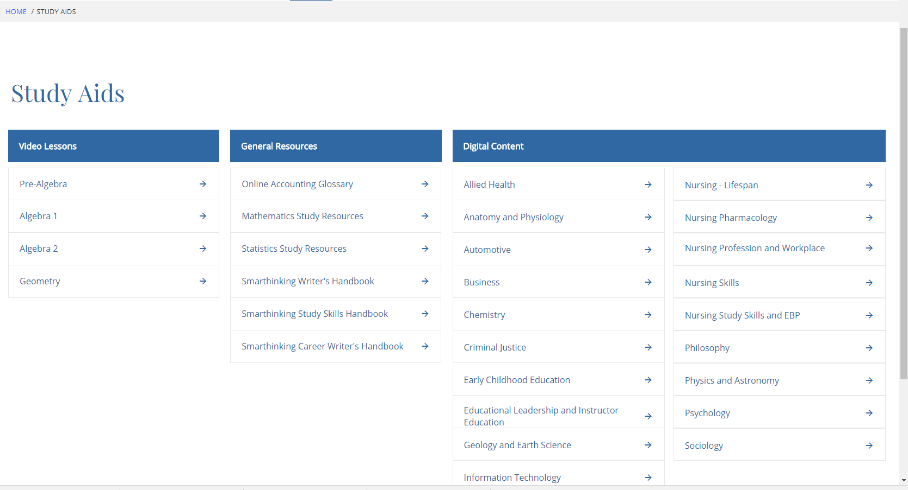

Technical Support
http://smarthinking.echelp.org/ 1-866-321-1004

