ThinkingStorm FAQs
What is ThinkingStorm?
ThinkingStorm provides live online tutoring to help students build skills, understand new material, and develop confidence as they pursue educational success.

Who has access to ThinkingStorm?
All Cedar Crest students, both undergraduate and graduate, have access to ThinkingStorm.

How do students access ThinkingStorm?
Students can access ThinkingStorm in Canvas via the course navigation menu.

When is ThinkingStorm available?
Online drop-in tutoring is available 24/7 for most subjects. Some more specialized subjects might require booking an appointment with a tutor in advance.

What subjects are available for online tutoring in ThinkingStorm?
Math: Basic Math through Calculus, including Introductory and Advanced Statistics
Science: Biology, Chemistry, Physics, Human Anatomy & Physiology
Writing: Submission-based writing feedback is available 24/7. Students receive feedback in approximately 18 hours, on average.
Business: Accounting, Finance, and Introductory Economics
Nursing: Medical Terminology, Pathopsychology, Pharmacology, and other topics
Technology: Adobe Creative Suite and Microsoft Office
Social Sciences: Political Science, Psychology, Sociology
Liberal Arts and Language: English, History, Spanish

How much does ThinkingStorm cost?
ThinkingStorm is free to all Cedar Crest students!

How are ThinkingStorm tutors selected?
Each of ThinkingStorm’s tutors go through a multi-round interview process during which they must demonstrate high-level subject expertise and effective pedagogy in a series of sample lessons. At ThinkingStorm, we hire online tutors with strong educational backgrounds and previous teaching experience. All of our tutors hold degrees in relevant fields, and over 65% hold advanced degrees related to the subjects they tutor.

Who do I contact with questions about ThinkingStorm?
You can contact Cedar Crest’s Academic Services at advising@cedarcrest.edu or ThinkingStorm Support at 877-889-5996 and care@thinkingstorm.com.
- Log into your course via Cedar Crest Online (Canvas)

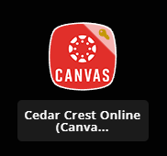

2) Click the ThinkingStorm link in your Canvas course menu

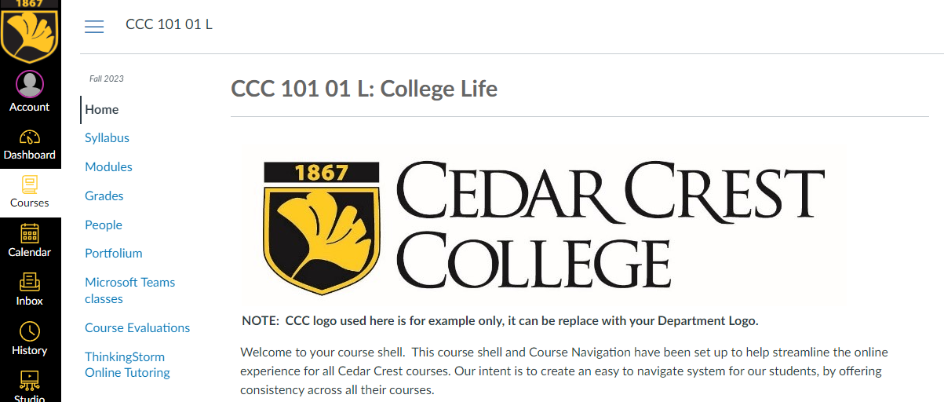

3) Use ThinkingStorm’s menu in your Canvas course to connect to Cedar Crest’s peer tutoring and our 24/7 online tutoring

