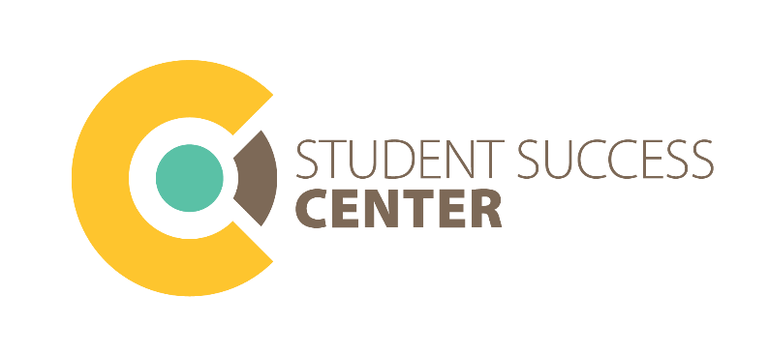

Academic Services – Writing Center Tutor
Position Description
Writing Center Tutors assist Cedar Crest students with improving their writing skills. Writing Center Tutors are trained to use student-focused, non-directive writing tutoring methodology to assist students with improving their writing skills so they can write effectively and successfully on the college level.
Responsibilities
Writing Center Tutors spend their scheduled shifts in the Writing Center in the Student Success Center, and meet with students by appointment. Writing Center Tutors typically work one-on-one with students, though small group sessions may occasionally occur. Some Writing Center Tutors hold online appointments as well.
Writing Center Tutors are expected to read all required training materials, undergo extensive “shadowing” with other Writing Center Tutors, and develop and maintain a strong working knowledge of both the APA and MLA format manuals. Other responsibilities include keeping current and accurate records of their tutoring sessions, attending trainings and meetings, assisting with new tutor training, directing students to other services and resources in the Student Success Center and on campus, and participating in workshop and resource development.
Applicant Requirements
- Cumulative GPA of 3.25 or higher
- Course grade of A- or higher in WRI 100 (A preferred)
- Excellent communication and listening skills
- Demonstrable academic writing skills and accuracy
- Ability to work collaboratively with others
- Dedication to helping other students
- Availability to work at least 4 hours per week
- Recommendation from faculty/staff member (preferred, but not required)
- Familiarity with APA and/or MLA format (preferred, but not required)
Benefits
Writing Center Tutors are paid by the hour. Raises may be given at the beginning of each academic year based on hours of experience. Working as a Writing Center Tutor provides collaborative experience, development of professional and leadership skills, and the opportunity to sharpen one’s own academic and writing skills.

